Signal Wiring
Thelio Main
Spec version 3

All wire lengths specified from the inside of the connectors.

EXAMPLE IMAGE

CABLE 1
Front panel power button to the backplane (Thelio-IO). 140mm 4-pin dupont to 4-pin dupont. Black connector. Multicolor 28 AWG wire.

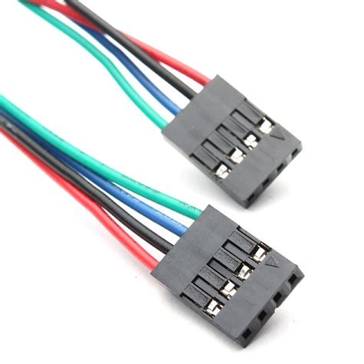

CABLE 2
Power button board to front panel. 70mm 4-pin dupont to individual 2.8mm spade with clear insulated sleeve. Multicolor 28 AWG wire.

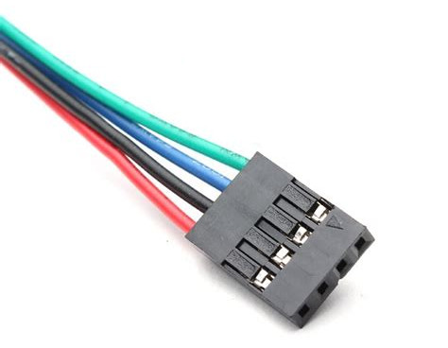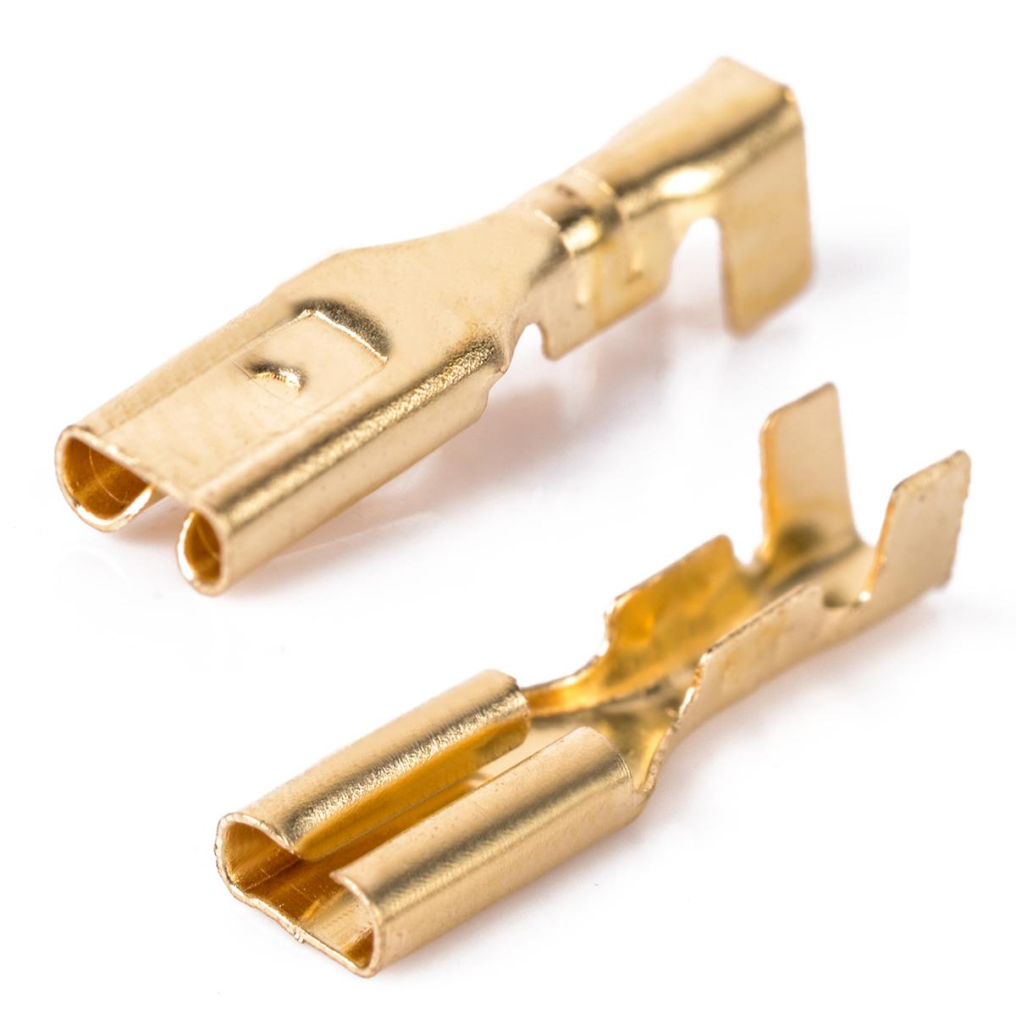

Backplane (Thelio-IO) to/from Motherboard

Backplane (Thelio-IO) 4-pin dupont to motherboard front panel header (2 x 2-pin dupont). 270mm multicolor 28 AWG wire.

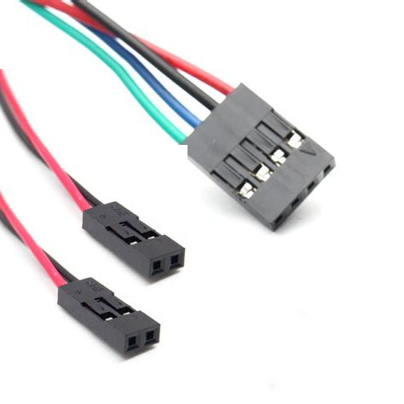

CABLE 5
Motherboard CPU 4-pin female fan connector to backplane (Thelio-IO) 4-female fan connector - 290mm black 28 AWG wire.

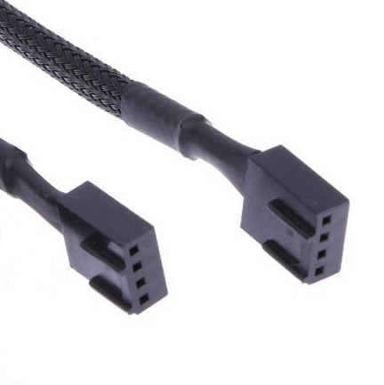

CABLE 6:
Backplane (Thelio-IO) backplane USB to USB connector. 150mm standard USB 2.0 header to USB 2.0 header.

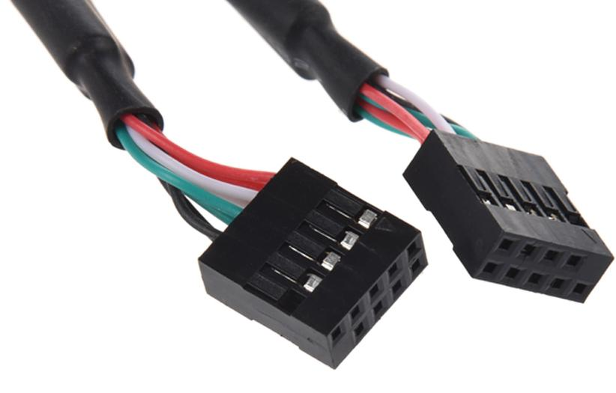

CABLE 7:
Wireless Antenna
2 x 330mm from the wireless card MHF4 connector to the antenna connect point. AMHF4 connector quality and proper crimping of the connector is essential. The connectors should not easily pop off of the terminal.

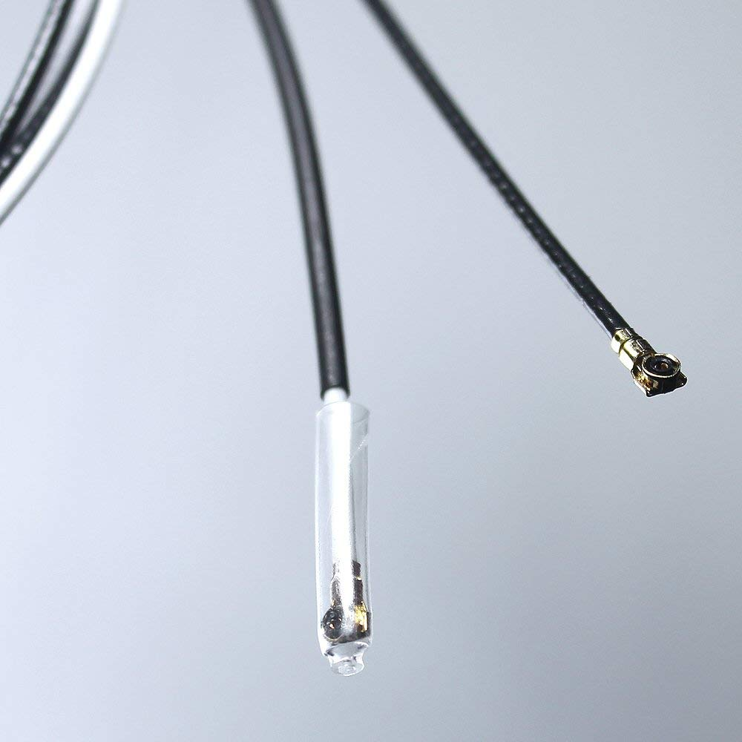

CABLE 7:
SATA
4 x 127mm straight to straight. Black.

